Arrive Home – BI Implementation Plan

Problem Statement
Arrive Home’s stakeholders face significant challenges with respect to the visibility of data across the loan lifecycle due to fragmented data, missing fields, and heavy reliance on manual reporting. Homebase’s current reporting is limited, requiring multiple clicks and lacking drilldowns. Critical data points from loan packages, servicing systems, and manual EEP workflows are not centrally unified, making it difficult to track conditions, turn times, lender performance, and operational bottlenecks. Dependence on manual spreadsheets and unstructured documents slows decision-making. Overall, the organization lacks a single source of truth that delivers timely, accurate, and actionable insights across DPA, White Label, EEP, servicing, and investor operations.

Need for BI
Business Intelligence (BI) is not just a “good-to-have” anymore — it has become a critical foundation for any modern project, whether it’s a product build, SaaS platform, enterprise solution, or internal operational system. Business Intelligence:
- Enables Data-Driven Decision Making - BI converts raw data into meaningful insights so teams don’t rely on assumptions or intuition
- Identifies Issues Early - With real-time dashboards and alerts, BI shows what’s working and what’s not.
- Improves Transparency Across Teams.
- Justify Business Decisions with Evidence.

Objective
The BI program aims to unify all lending, servicing, and operational data into a single, reliable analytics platform that delivers timely, accurate, and drill-down reporting. It will replace manual workflows and fragmented reports with automated, scalable Power BI dashboards that provide full visibility across DPA, White Label, and EEP business lines.

Data Sources & Integration Points
System/Source | Data Type | Integration Status
Homebase MongoDB | Loan applications, borrower data, loan servicing | Primary - Direct MongoDB connection
Black Lake Processing | MISMO document parsing, JSON loan packages | In transition - API integration planned
VisionNet QA | Data quality checking, document validation | May be eliminated - File-based reports
BSI Servicing | Second mortgage servicing data | File-based data feeds to Homebase
ServBank | First mortgage servicing data | File-based data feeds to Homebase
Data Tape Securitization | Securitized loan portfolios | Uploaded to Homebase - Spreadsheet format

Current Business Process Flow
Understanding the current loan processing workflow is critical for identifying data collection points and automation opportunities:
- Correspondent lender initiates loan in Homebase and submits MISMO document (industry standard XML loan package)
- ArrivehHome returns funding obligation letter enabling correspondent to close the first mortgage
- After closing, correspondent sends complete loan package (hundreds of pages PDF) to ArrivehHome
- Black Lake vendor processes PDF package into segmented documents and structured JSON data
- VisionNet quality assurance team validates data accuracy and completeness
- Internal processing team manually transfers data from spreadsheets to Homebase system
- Loan is purchased and sent to appropriate servicer (BSI for second mortgage, ServBank for first mortgage)
- Ongoing servicing data is received via file feeds and imported into Homebase for portfolio management

BI and Data Architecture
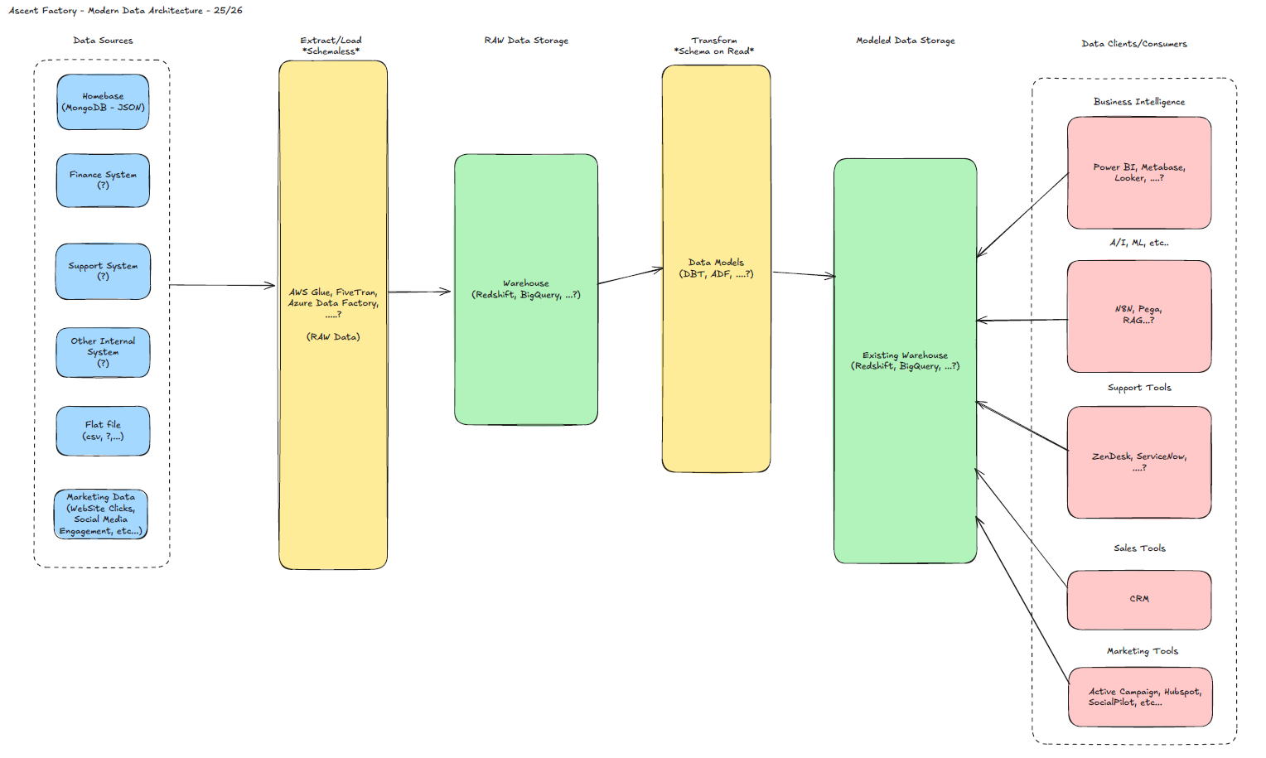
Data Sources – These are all the sources where your business data originates.
Extract Layer - Tools like AWS Glue, FiveTran, or Azure Data Factory connect to your source systems and copy the data as-is into your data warehouse
Raw Data Storage - The raw data lands in a data warehouse (like Redshift or BigQuery) in its original format.
Transform Layer - This is where tools like DBT (Data Build Tool) read the raw data and transform it into useful structures.
* The "Schema on Read" approach means you decide how to structure the data based on what questions you need to answer, rather than pre-defining everything upfront.
Modelled Data Storage - The transformed, clean, business-ready data sits here in well-organized tables and views.
Data Clients/Consumers - Finally, various tools and teams access this clean data.

Key Benefits of This Architecture
- Flexibility - You keep all raw data, so you can always re-transform it differently if business needs change
- Auditability - Raw data is preserved, so you can always trace back to the source
- Speed - Loading raw data is fast; transformation happens later when warehouse has more computing power

Implementation Plan – In Phases

Phase 1 – Discovery & Requirements
Objective:
- Understanding the scope of work
- Collect full list of required reports from each stakeholder
- Working on the implementation plan and requirements documentation.
Deliverables:
- Implementation Plan
- Requirements document

Phase 2 – Data Requirements
- Document all existing fields in Homebase
- Identify missing fields and work with engineering to add them
- Validate PDF-extractable fields
- Prioritize key business metrics
- Establish data dictionary
- Define Data Contracts
- Build Raw Ingestion Pipelines
- Implement Raw Storage Zone
- Set Up Metadata Catalog + Lineage
Deliverables:
- Data Requirements Document
- Gap Analysis
- List of New Fields to be added in Homebase (if any)

Phase 3 and 4 – Data Pipeline & Data Warehouse Build
Objectives:
- Build APIs or connectors for Homebase
- Ingest extracted PDF fields
- Create staging → curated models
- Implement data quality rules
- Handle schema versioning
(as suggested by Dave)
- Project Setup
- Core Staging Models
- Curated Dimensional Models
- Core Fact Tables
- Data Quality Framework
Deliverables:
- Azure SQL data warehouse
- Automated ETL jobs
- Version-controlled datasets
- Initial fact and dimension tables

Phase 5 – Dashboards & Reports
Objective:
- To build reports and dashboards for:
  - Operations
  - Compliance
  - Finance
  - Executive
Deliverables:
- BI Datasets & RLS
- Dashboard Build-Out
- Exportable report templates

Suggested Dashboards and Reports

Purchase Clearing – Conditions Created Dashboard (From Ron’s document)
Purpose: Volume & type of conditions created
Drill-downs include:
- Loan Number
- Lender
- Condition Type
- Created Date

Purchase Clearing – Conditions Cleared Dashboard (From Ron’s document)
Purpose: Productivity & turn times by clearer
KPIs:
- Avg Turn Time (Created → Cleared)
- Volume cleared by specialist

Loans Purchased Dashboard (From Ron’s document)
Purpose: Purchase volume + turn time KPI
Fields required:
- Closing Package Received Date
- Purchased Date
- Specialist Performance

Open Loans (Not Purchased) Dashboard (From Ron’s document)
Purpose: Current workload + SLA risk (10-day SLA)
Aging buckets:
- 3–5 days
- 6–8 days
- 9–10 days
- 11+ days

Executive Pipeline Snapshot (As per Nik)
Using Homebase fields shown in the Homebase dashboard demo in the transcript
(Registrations, Locks, Product Types, Lending Stats)
Metrics included:
- Loans Registered Today / Week
- Loans Locked
- Loans Funded
- Loan Amount Distribution
- Filters: Date, Product, Correspondent/Lender

Lender Performance Scorecard (DPA)
Includes:
- Loans Purchased
- Avg Conditions per Loan
- Avg Time (1st Condition → Last Condition)
- Avg Time (Last Condition → Purchase)
- Avg Time (CP Received → Purchase)

PCS Turn Time Dashboard (Purchase Clearing Specialists)
KPIs:
- Conditions per loan
- Avg Specialist Turn Time
- Purchase Volume by Specialist

DPA Workflow Dashboard (Black Lake)
Using the detailed DPA flowchart with validations and condition logic:
(page visual shows each step from Appraisal → Note → CD1 → CD2 → DOT → Insurance → Taxes → Fraud checks, etc.)
This dashboard helps track:
- Missing Documents
- Validation Failures
- Time spent in each stage
- Total Conditions per loan

Correspondent (Lender) Volume & Trend Dashboard
Using Homebase filters discussed in transcript:
- Loans by lender
- Avg loan amount
- Registrations today/this week
- Lock activity (daily & lender-wise)

Enterprise Executive Dashboard
Cross-domain KPIs from BI Scope Document :
- Monthly loan volume
- DPA vs White Label vs EEP comparison
- Warehouse usage (South Star Bank)
- Servicing performance summary
- Portfolio aging
- Securitized vs retained loans

Securitization & Investor Reporting
Includes:
- Pool composition
- Weighted averages (rate, FICO, DTI)
- Prepayment & delinquency trends
- USF / Ginnie Mae reporting

EEP Program Dashboard
(EEP workflows currently spreadsheet-based; requires integration)
Tracks:
- First / Second Mortgage / Lease data
- Property purchase → tenant reporting
- Equity earned trajectory
- Performance & risk

Servicing Performance Dashboards
Using BSI & ServBank feeds:
- Delinquency buckets
- Collections performance
- Repurchase triggers
- Default rates by correspondent

Forecasting Models (AI/ML-lite using Power BI AutoML)
- Loan volume forecasting
- SLA breach prediction (for clearing)
- Staffing optimization models

Funding & Purchase Reconciliation Report
Purpose: Ensure BI numbers match the company’s actual cash activity.
Fields/KPIs:
- Loan purchase amount
- Amount wired vs amount recorded
- Variance detection
- Funding date, Purchase date
- Error flags

Loan Vision vs BI Variance Report (GL Reconciliation Report)
Purpose: Compare BI-calculated financial totals with GL totals in Loan Vision.
Fields/KPIs:
- Monthly funding totals
- Warehouse interest
- Purchase balances
- Variances (BI → Loan Vision)

BSI / ServBank Servicing Reconciliation Report
Purpose: Ensure correspondence between servicing systems and Arrive Home records.
Fields/KPIs:
- Payment received
- Delinquency status
- Repurchase triggers
- Servicing balances
- Variance flags

Loan-Level Financial Drilldown (50-Field Loan Master Report)
Purpose: Ability to drill into every data point on a loan for self-service.
Fields:
- Full loan attributes
- Financial fields (UPB, interest, fees)
- Conditions
- Purchase status
- Servicing fields
- Cash movements

Warehouse Line Utilization & Cash Flow Report
Purpose: Track warehouse usage (South Star Bank) and ensure cash movement accuracy.
KPIs:
- Daily warehouse balance
- Cash in/out
- Funding per correspondent
- Interest charged
- Unused capacity

End-of-Month Close Financial Dashboard
Purpose: Speed up accounting close by giving finance controlled, validated numbers.
KPIs:
- Monthly funded loans
- Purchases
- Conditions pending at close
- Loan Vision alignment
- Servicing variances
- Journal entry generator dataset (future phase)

EEP Post-Closing Compliance Dashboard
This dashboard tracks the status of every required EEP document.
KPIs:
- % of loans with completed 2nd Note / Allonge / DOT
- % recorded vs unrecorded
- Loans with missing or incorrect Exhibits
- Aging of outstanding items
- By Audit Team Member, Servicing Member, and Lender

EEP Exception & Deficiency Report
Because several notes indicate data problems (missing documents, wrong addresses, missing AOM, incorrect Exhibit A), there must be a dedicated exception report.
KPIs:
- Count of exceptions by type
- Exceptions by loan age
- Exceptions by Audit Team Member
- “High-risk” exceptions (e.g., unrecorded DOT)
- Exception resolution aging

EEP Recording & Compliance Timeliness Report
This report helps eliminate compliance risk for the EEP program.
KPIs:
- Avg days from funding → recording
- SLA compliance (e.g., DOT must be recorded within X days)
- Loans past recording deadlines
- Time between document events

Collateral Document Compliance Dashboard
Tracks the status of the required second-mortgage collateral package, similar to the EEP tracking but for all second mortgages.
KPIs:
- % of files with complete collateral
- % missing “Original DOT”
- % missing Note
- % missing NON-Recorded DOT
- Exceptions by funding month
- Exceptions by audit/servicing member
- Loans pending receipt of collateral
- “Any Issues With the File” → exception counts

CSP Consistency / Data Accuracy Report
Confirms whether the MIN and loan details are correct between:
- Homebase
- CSP portal
- Collateral file
- Data warehouse
KPIs:
- Records marked “Verified = FALSE”
- MIN mismatches
- Loan amount mismatches
- Borrower mismatches
- Aging of unresolved discrepancies

Static Reports (Downloadable)
- Daily loan pipeline report (Excel/PDF)
- Registrations & locks summary
- Lender exception report
- Funding report
- Audit report (who changed what and when)

Risks & Mitigation
Risk | Mitigation
Homebase schema changes | Implement schema versioning + decouple ingestion
Missing fields | Stakeholder field inventory + engineering JIRA tickets
Complex servicing feeds | Define data contracts early (BSI, ServBank)
Manual EEP workflows | Document early; design interim ingestion
Under-spec’d Black Lake metadata formats | Validate early using sample DPA packages

